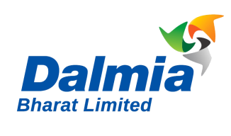
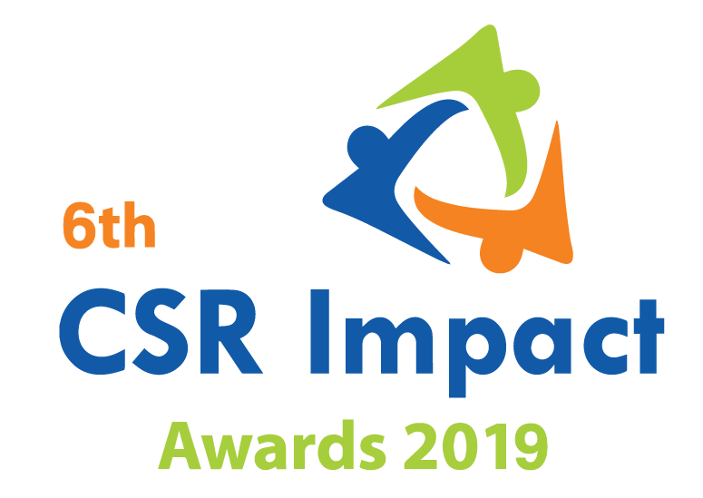

Only CSR Implementing Agency |  | Small
 |  | Large

India CSR Summit & Exhibition 2019
6th CSR Impact Awards 2019-Application Form (Category 14)

Please select the Category (Only one category/each form, for more than one category submit separate form and read the guidelines)
1 | Healthcare | ***
2 | Education | ***
3 | Skills Development | ***
4 | Livelihoods | ***
5 | Environment | ***
6 | WASH (Water, Sanitation and Hygiene) | ***
7 | Women Empowerment | ***
8 | Rural Development and Infrastructure | ***
9 | Special Categories (Old Age, Specially-abled and others) | ***
10 | Employee Volunteering Initiative | ***
11 | CSR Project of the Year 2018-19 | ***
 | Special Award
12 | CSR Foundation of the Year 2018-19 (only for CSR Foundation) | ***
13 | Company with Best CSR Impacts (2018-19) Only for companies | ***
14 | CSR Implementing Agency of the Year 2018-19 (For implementing agency only)

(Please read the award-guidelines carefully before submitting this form)
Please send filled in form and application fee to the address below and email a copy to csrimpactawards@gmail.com

NGOBOX (Renalysis Consultants Pvt Ltd)
B-1005, Titanium Heights, Opp. Vodafone House, Corporate Road, Prahalad Nagar,
Ahmedabad 380051 (Gujarat)
Call +91-9560352170/ +91-9971429654

Please provide the application fee information here
Application Fee: INR
Paid vide Cheque/DD/NEFT:
Date:
Comment:

Date: Location:

Part A: Organizational Profile

A1 | Name of the organization applying for the Award (Full Name) (Please do not use acronym)
A2 | Office Address | Address:  Contact No.
A3 | Contact Person for this application (This will be the nodal contact point for this application) | Name:  Designation:  Mobile:  Email:  Alternate Contact no.
A4 | Organization website
A5 | Type of organization
A6 | Name of the CEO/President/Director
A7 | By submitting this application form, the organization agrees to provide all the project related information during the assessment process and will abide by the rules set by the organizers. The applicant also acknowledges that all the information provided in this application form is correct.
 | Seal, Name and Signature of Authorized Representative

Part B: Project& Programme Details

Give a brief introduction of the organization (200 words)
What are the main CSR Projects & Programmes that the organization is implementing for last 2 years
States/geographic description of the operations of the organization
Who have been major CSR funding partner for your organization
What was the annual CSR funding received by the organization in FY 2018-19 (INR)
What was the overall actual CSR spend of the organization in FY 2018-19)

Part C: Projects & Programme Summary

C.1. Enlist flagship CSR programmes implemented by the organization
S.no. | Programme/Projects | Geographic coverage | CSR project of company | Project budget in FY 2018-19 (INR)

C.2. Briefly describe three main CSR programmes implemented by the organization with focus on programme objectives, operations plan, partners, geographic coverage, resource usage, monitoring and impacts. (500 words for each programme)

Part D.1: Please describe how all of the above projects were identified and selected for implementation? (400 words)

Part D.2: How were the company and implementing partners innovative in CSR planning, projects implementation and monitoring of the projects? What have been impediments in the CSR projects/programme management at the grass-root level? (700 words)

Part D.3: How did the organization try to leverage its expertise while implementing projects? (400 words)

Part D.4: What has been the major projects achievement since its beginning? (500 words)

Part D.5: What was so specific and outstanding in FY 2018-19 in terms of CSR projects and programmes implemented by your organization? Please provide major impact matrix along with resources used in each of the project in FY2018-19. (700 words)

Part E: Why do you think that the organization should be selected for the ‘Implementing agency of the year 2018-19? Please provide due justification of the each of the points.

Part F: Your contribution towards achieving SDGs: Please elaborate how did your projects/program help India in moving closer to achieving the SDGs?

SDGs | Projects | Impact for SDGs

Annexure
- Please add appropriate Annexure like tables, images, diagrams, media-reports, and web-links). In case you wish to submit a Power point presentation for the project, please send the same along with the application. The maximum number of slides: 10)
- In case you wish to enclose a report or any other documentary proof, please send the same along with the hard copy of the application form and mention the same here.

__***___

