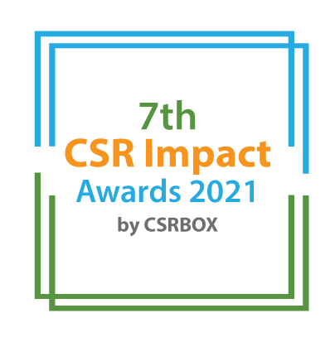
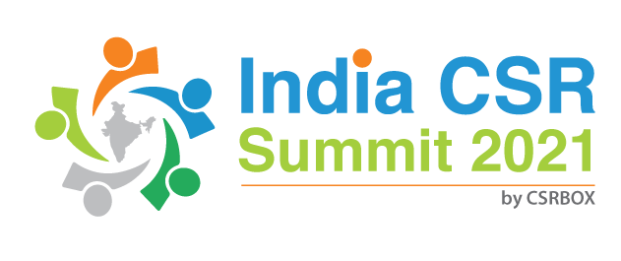

India CSR Summit 2021

Only for the CSR Implementing Agency as per the Companies Act 2013 | Project Category (Tick as applicable)
 |  | Small
 |  | Large
7th CSR Impact Awards 2021-Application Form (Category 14)

Please select the Category:

 | Category (Please tick in front of the appropriate category)
1 | Healthcare (Non-COVID Project) | ***
2 | Education | ***
3 | Skills Development | ***
4 | Livelihoods | ***
5 | Environment | ***
6 | WASH (Water, Sanitation and Hygiene) | ***
7 | Women Empowerment | ***
8 | Rural Development and Infrastructure | ***
9 | Special Categories (Old Age, Specially-abled and others) | ***
 | Special Awards | ***
10 | Employee Volunteering Initiative | ***
11 | CSR Project of the Year 2020-21 | ***
12 | CSR Foundation of the Year 2020-21 (only for CSR Foundation) | ***
13 | Company with Best CSR Impacts (2020-21)Only for companies | ***
14 | CSR Implementing Agency of the Year 2020-21 For implementing agency only)
15 | COVID19 Response | ***
***Please use the specific application template for other categories, given on the website)
(Please read the award-guidelines carefully before submitting this form)

Submission of Applications
- Please send filled-in form along with all the attachments, and application fee details at awards@csrbox.org
- We are accepting online applications only, hence all the supporting documents (optional) need to be sent in e-version only.

Please provide the application fee information here

Application Fee: INR
Paid vide Cheque/DD/NEFT:
Date:
Comment:

Part A: Organizational Profile

A1 | Name of the organization applying for the Award (Full Name) (If you are using any brand name, add that after the full name)
A2 | Office Address | Address:  Contact No.
A3 | Contact Person for this application (This will be the nodal contact point for this application and all the communication will be addressed to the given email id) | Name:  Designation:  Mobile (preferably with WhatsApp):  Email:  Alternate Contact no.
A4 | Organization website’s url
A5 | Type of organization
A6 | Name of the Authorized Person (Director/Head of the Organization
A7 | By submitting this application form, the organization agrees to provide all the project related information during the assessment process and will abide by the rules set by the organizers. The applicant also acknowledges that all the information provided in this application form is correct.
 | Please mark the authorised person on the email while sending the award application by email.

Part B: Organization’s Scale

Give a brief introduction of the organization (200 words)
What are the main CSR Projects & Programs that the organization is implementing for last 2 years
States/geographic description of the operations of the organization
Provide the list of major CSR funding partner/partners for your organization
What was the annual CSR funding received by the organization in FY 2020-21 (INR)

Part C: Projects & Program Summary
C.1. Enlist flagship CSR programmes implemented by the organization

S. No. | Program/Projects | Geographic coverage | CSR project of company | Project budget in FY 2020-21 (INR)

C.2. Briefly describe three main CSR program implemented by the organisation with focus on program objectives, operations plan, partners, geographic coverage, resource usage, monitoring and impacts. (500 words for each program)

Part D: Programs and Impacts

Part D.1: Please describe how all of the above projects were identified and selected for implementation? (400 words)

Part D.2: How were the company and implementing partners innovative in CSR planning, projects implementation and monitoring of the projects? What were the impediments in the CSR projects/ program management at the grass-root level. (700 words)

Part D.3: How did the organization try to leverage its expertise while implementing projects with specific to COVID19 impacts, and re-alignment required for CSR projects? (400 words)

Part D.4: What have been the major achievement of the organization through CSR projects in FY2020-21, please elaborate for each of the key projects? (500 words)

Part D.5: Why do you think that the organization should be selected for the ‘Implementing agency of the year 2020-21? Please provide due justification of the each of the points.

Annexure (All documents need to be submitted in e-version)
- Please add appropriate annexure like tables, images, diagrams, project-briefs, media-reports, web-links in this section with a brief note for each of the link.

S. No. | Web-link | Brief note about the link

__End__

