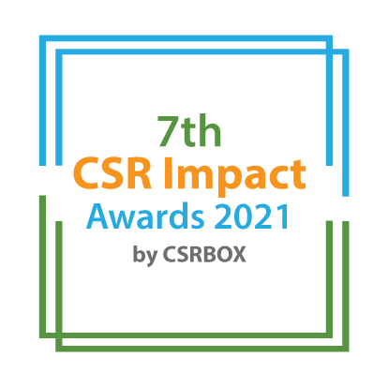

India CSR Summit 2021

Only for CSR Foundations | Project Category (Tick as applicable)
 |  | Small
 |  | Large
7th CSR Impact Awards 2021-Application Form (Category 12)

Please select the Category:

 | Category (Please tick in front of the appropriate category)
1 | Healthcare (Non-COVID Project) | ***
2 | Education | ***
3 | Skills Development | ***
4 | Livelihoods | ***
5 | Environment | ***
6 | WASH (Water, Sanitation and Hygiene) | ***
7 | Women Empowerment | ***
8 | Rural Development and Infrastructure | ***
9 | Special Categories (Old Age, Specially-abled and others) | ***
 | Special Awards | ***
10 | Employee Volunteering Initiative | ***
11 | CSR Project of the Year 2020-21 | ***
12 | CSR Foundation of the Year 2020-21 (only for CSR Foundation)
13 | Company with Best CSR Impacts (2020-21)Only for companies | ***
14 | CSR Implementing Agency of the Year 2020-21 For implementing agency only) | ***
15 | COVID19 Response | ***
***Please use the specific application template for other categories, given on the website)
(Please read the award-guidelines carefully before submitting this form)

Submission of Applications
- Please send filled-in form along with all the attachments, and application fee details at awards@csrbox.org
- We are accepting online applications only, hence all the supporting documents (optional) need to be sent in e-version only.

Please provide the application fee information here

Application Fee: INR
Paid vide Cheque/DD/NEFT:
Date:
Comment:

Part A: Organizational Profile

A1 | Name of the organization applying for the Award (Full Name) (If you are using any brand name, add that after the full name)
A2 | Office Address | Address:  Contact No.
A3 | Contact Person for this application (This will be the nodal contact point for this application and all the communication will be addressed to the given email id) | Name:  Designation:  Mobile (preferably with WhatAspp):  Email:  Alternate Contact no.
A4 | Organization website’s url
A5 | Type of organization | CSR Foundation/Trust
A6 | Name of the Authorized Person (Director/Head of the Organisation
A7 | By submitting this application form, the organization agrees to provide all the project related information during the assessment process and will abide by the rules set by the organizers. The applicant also acknowledges that all the information provided in this application form is correct.
 | Please mark the authorised person on the email while sending the award application by email.

Part B: Project & Program Details

Give a brief introduction of the organization (200 words)
What are the main CSR focus areas of the organization
Please mention key operations geography (States) of the Foundation
Does the organization implement CSR projects on its own or through other implementing partners
What was the annual CSR budget of the foundation in FY 20-21 (INR)
Part C: Projects & Program Summary

C.1. Enlist 3-4 flagship programs of the foundation.
S. No. | Program/Projects | Geographic coverage

C.2. Briefly describe three main programs of the foundation with focus on programs objectives, operations-plan, partners, geographic coverage, resource usage, monitoring and impacts. (500 words for each programs)

Part D: CSR Foundation & Program Impacts

Part D.1: How did the foundation identify CSR projects need and beneficiaries? What was the implementation model for key programs (300 words)

Part D.2: How was the foundation innovative and pragmatic in CSR planning, projects implementation and monitoring of the projects? (700 words)

Part D.3: How did the organization try to leverage its expertise and scale up the operations? (400 words)

Part D.4: What were the major achievements of the foundation in FY 2020-21 and how was the foundation aligned with the COVID19 impacts on projects? (500 words)

Part D.5: Why do you think that the Foundation should be considered for the ‘CSR Foundation of the Year 2020-21? (600 words)

Annexure (All documents need to be submitted in e-version)
- Please add appropriate annexure like tables, images, diagrams, project briefs, media-reports, web-links in this section with a brief note for each of the link.

S. No. | Web-link | Brief note about the link

__End__

