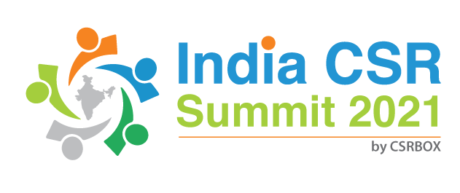
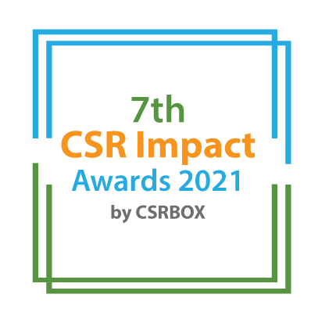

India CSR Summit 2021

7th CSR Impact Awards 2021-Application Form (Category 10)

Please tick the category

 | Category (Please tick in front of the appropriate category)
1 | Healthcare (Non-COVID Project) | ***
2 | Education | ***
3 | Skills Development | ***
4 | Livelihoods | ***
5 | Environment | ***
6 | WASH (Water, Sanitation and Hygiene) | ***
7 | Women Empowerment | ***
8 | Rural Development and Infrastructure | ***
9 | Special Categories (Old Age, Specially-abled and others) | ***
 | Special Awards | ***
10 | Employee Volunteering Initiative
11 | CSR Project of the Year 2020-21 | ***
12 | CSR Foundation of the Year 2020-21 (only for CSR Foundation) | ***
13 | Company with Best CSR Impacts (2020-21)Only for companies | ***
14 | CSR Implementing Agency of the Year 2020-21 For implementing agency only) | ***
15 | COVID19 Response | ***
***Please use the specific application template for other categories, given on the website)
(Please read the award-guidelines carefully before submitting this form)
Submission of Applications
- Please send filled-in form along with all the attachments, and application fee details at awards@csrbox.org
- We are accepting online applications only, hence all the supporting documents (optional) need to be sent in e-version only.

Please provide the application fee information here

Application Fee: INR
Paid vide Cheque/DD/NEFT:
Date:
Comment:

Note: This category does not have any specific criteria for the assessment. Even though quality of volunteering work, selection of partners/initiatives and options available to an employee for volunteering will have more focus during the assessment/evaluation). The screening team and jury may develop specific criteria for the qualitative evaluation.

Part A: Organizational Profile

A1 | Name of the organization applying for the Award (Full Name) (Please do not use acronym)
A2 | Office Address | Address:  Contact No.
A3 | Contact Person for this application (This will be the point of contact. All the information and updates will be shared on the given email id). | Name:  Designation:  Mobile:  Email:  Alternate Contact no.
A4 | Organization’s website
A5 | Type of organization | Company  CSR Foundation/Trust
A6 | Name of the CSR or EVP Head
A7 | By submitting this application form, the organization agrees to provide all the project related information during the assessment process and will abide by the rules set by the organizers. The applicant also acknowledges that all the information provided in this application form is correct.

Part B: Project Details

B1 | Title of the project
B2 | Project geography (Specify details like state, district, blocks etc.)
B3 | Total no. of beneficiaries the project intended to reach
B4 | Total no. of beneficiaries that the project could reach
B5 | Name of the company/companies which has/have given support through Employee Volunteering
B6 | Which are the other partners/institutional engagements in the project? (name of implementing Partners, NGOs, Community bodies etc.)
B7 | When did the project start and when does it intend to end/ended | Start date:  End date:
B8 | Financial Information | Was there any financial contribution/matching grant or other similar mecahnsim in Employee Volunteering Initiative? Please provide details.

Part C: Project Summary (Maximum 800 words)

Part D: Project Details

D1: Basic Information

Please give the Company’s headquarter/Corporate office City name
How many employees volunteered in FY 2020-21
Total number of employees in organization as on 31st March 2021
How many hours of contribution was made in volunteering in FY 2020-21
Was the volunteering majorly done during working hours?
Did the employee volunteer during weekends/holidays as well?
Who coordinates with employees and organizations with whom employees’ volunteer? | - Human Resources Department  - CSR Team/Department  - PR/Communication Team
Who all from the top five executives (top management) of the company volunteered for a cause in FY 2020-21? Please provide brief information.
Is employee volunteering a part of employee performance assessment?
Is there any maximum limit of time/Hours that an employee can go for volunteering in a month/Year? Please provide details?
Does your organization have a policy/guidelines/Manual on employee volunteering? If yes, please provide a key pointers of the same? (Max. 400 words)

D2: Volunteering Information

D2.1: What were the causes/initiatives for which your employees volunteered in FY 2020-21?
D2.2: Enlist NGO/Civil Society/Local Partner for employee volunteering and Locations in 2020-21?

D2.3: How do you select a cause and partners for volunteering? (Max.250 words)

D2.4: How did EVP made impacts/difference to the cause? Please give initiative-wise information? (Max. 150 words for each cause/campaign)

D2.5: What type of major volunteering it was? Technical support in line with employees’ professional background or general volunteering as per the requirement of the partner organization/campaign.? Please elaborate (Max. 300 words)

D2.6: What are the major inputs/concerns/learning among employees after volunteering with NGOs/for a cause/campaign?

Annexure (All documents need to be submitted in e-version)
- Please add appropriate annexure like tables, images, diagrams, project brief, media-reports, web-links in this section with a brief note for each of the link.

S. No. | Web-link | Brief note about the link

__End__

