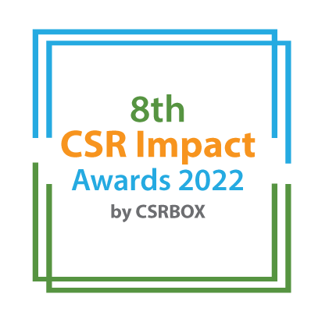

India CSR Summit 2022

Only for the companies mandated for CSR under the Companies Act 2013 | Project Category (Tick as applicable)
 |  | Small
 |  | Large
8th CSR Impact Awards 2022-Application Form (Category 13)

Please select the Category:

 | Category (Please tick in front of the appropriate category)
1 | Healthcare (Non-COVID Project) | ***
2 | Education | ***
3 | Skills Development | ***
4 | Livelihoods | ***
5 | Environment | ***
6 | WASH (Water, Sanitation and Hygiene) | ***
7 | Women Empowerment | ***
8 | Rural Development and Infrastructure | ***
9 | Special Categories (Old Age, Specially-abled and others) | ***
 | Special Awards | ***
10 | Employee Volunteering Initiative | ***
11 | CSR Project of the Year 2021-22 | ***
12 | CSR Foundation of the Year 2021-22 (only for CSR Foundation) | ***
13 | Company with Best CSR Impacts (2021-22) Only for companies
14 | PSU with Best CSR Impacts (FY 2021-22) (only for Public Sector Undertakings/Enterprises) | ***
15 | CSR Implementing Agency of the Year 2021-22(For implementing agency only) | ***
16 | COVID19 Response | ***

***Please use the specific application template for other categories, given on the website)
(Please read the award-guidelines carefully before submitting this form)

Submission of Applications
- Please send the filled-in form along with all the attachments, and application fee details at awards@csrbox.org
- We are accepting online applications only, hence all the supporting documents (optional) need to be sent in e-version only.

Please provide the application fee information here

Application Fee: INR
Paid vide Cheque/DD/NEFT:
Date:
Comment:

Part A: Organizational Profile

A1 | Name of the organization applying for the Award (Full Name) (If you are using any brand name, add that after the full name)
A2 | Office Address | Address:  Contact No.
A3 | Contact Person for this application (This will be the nodal contact point for this application and all the communication will be addressed on the given email id) | Name:  Designation:  Mobile (preferably with WhatsApp):  Email:  Alternate Contact no.
A4 | Organization’s website URL
A5 | Type of organization | Company
A6 | Name of the Authorized Person (Director/Head of the Organization
A7 | By submitting this application form, the organization agrees to provide all the project related information during the assessment process and will abide by the rules set by the organizers. The applicant also acknowledges that all the information provided in this application form is correct.
 | Please mark the authorised person on the email while sending the award application by email.

Part B: Project & Program Details

Give a brief introduction of the organization (200 words)
What are the main CSR focus areas of the organization?
Does the organization implement CSR projects on its own or through other implementing partners or CSR foundations?
What was the annual CSR budget of the company in FY 2021-22 (INR)
What was the actual CSR spend of the Company in FY 2021-22

Part C: Projects Summary
C.1. Enlist 3-5 CSR flagship projects of the organization
S.no. | Programs/Projects | Geographic coverage | Implementation Partners

C.2. Briefly describe three main CSR projects of the company with a focus on objectives, operations-plan, partners, geographic coverage, resource usage, monitoring and impacts. (500 words for each project)

Part D: Projects and Impacts

Part D.1: How did the company identify CSR project’s needs and beneficiaries? (400 words)

Part D.2: How were the company and implementing partners innovative in CSR planning, project implementation and monitoring of the projects? (700 words)

Part D.3: How did the organization try to leverage its expertise and scale up the operations? (400 words)

Part D.4: What were the major CSR achievements of the company in FY 2021-22? How did COVID19 impact the CSR project implementation and how did you tweak or re-align projects for the pandemic impacts? (500 words)

Part D.5: How was the top management of the organization involved in CSR planning? (400 words)

Part D.6: Why do you think that the company should be considered for the award ‘Company with Best CSR Impacts’? Please provide a detailed justification of the impacts made through CSR interventions. (500 words)

Annexure (All documents need to be submitted in e-version)
- Please add appropriate annexures like tables, images, diagrams, project briefs, media reports, and web-links in this section with a brief note for each of the links.

S. No. | Web-link | Brief note about the link

__End__

