5th CSR Impact Awards 2018- Winners

NGOBOX’s 5th CSR Impact Awards 2018 was held on the sidelines of India CSR Summit 2018 on 24th and 25th September, 2018 at J W Marriott, Aerocity, New Delhi. It is an initiative of NGOBOX to encourage companies, CSR foundations and CSR implementing agencies to deliver high impacts through CSR projects and adopt multi-stakeholder approach leading to excellence in project outcome. The 5th CSR Impact Awards, co-presented by Dalmia Bharat Group recognized 22 exceptional projects in various categories of education, WASH, livelihood, etc out of an overwhelming response of 110 application forms from all over the country.
Present at the awards ceremony were Sh. Anant Kumar Hegde, Hon'ble Minister of State, Ministry of Skill Development And Entrepreneurship, Government of India, Dr. Satyapal Singh, Minister of State-HRD, Mr. Mahendra Singhi, Group CEO-Cement, Dalmia Cement Ltd, Padma Shri Mr. Sushil Gupta, Chairman and Managing Director, Asian Hotels (West). The applications were reviewed on a prior level by a panel of esteemed jury members coming from distinguished domains of expertise.
The Jury Members were:
- Mr. Abhishek Grover, Head- Community Engagement, Rustmojee Academy for Global Careers
- Mr. Abhishek Kumar, CSR Domain expert Head- DNR Foundation, Formerly with Samsung CSR Team
- Mr. Anurag Sinha, Lead Development Specialist, Japan International Cooperation Agency (JICA)
- Mr. Clement Chauvet (VC), Chief of Skills and Business Development, UNDP
- Dr. Archana Shukla Mukherjee, Manager, Business Development and Marketing Change Alliance Pvt Ltd
- Dr. K K Upadhyay, Former Head, Corporate Social Responsibility at FICCI
- Dr. Ashish Sabharwal, Sr. Consultant, Ex Vice President & Regional Director, South East Asia, Smile Train
- Mr. Gaurav Kapoor, Sr. Head - Industry Partnership, CSR, Media & Advocacy, NSDC
- Mr. Gaurav Shah (VC), Founder and Dean, ISDM
- Ms. Isha Bhandari, Ex-CEO, Chairperson, Sun Foundation, DSB Foundation
- Ms. Padma Buggineni (VC), Health & Nutrition Specialist, The World Bank
- Ms. Prachi Nautiyal, Director, Corporate Partnerships, United Way Mumbai
- Ms. Rachna Sujay, Senior Technical Advisor, FHI 360, Alive and Thrive Project
- Ms. Shruti Sharma, Resource Mobilization Manager, International Committee of the Red Cross
- Dilip Surkar, Country Programme Manager-UNDP-GEF/SGP, Executive Director, Vikram A Sarabhai Community Science Centre
- Swadesh Kumar Saxena, Head- Asmita Project, Arvind Ltd.
- Dr. R.N.Prasad, Director, The Centre For Entrepreneurship Development (A Govt. Of Gujarat Organization)
- Dr. Hina Shah, Founder & Ceo, ICECD
- Prof. Tara Nair, Professor, Gujarat Institute Of Development Research, Ahmedabad
- Prof. H. S. Shylendra, Professor, Social Science, Centre For Sustainable Livelihood, And Centre For Rural-Urban Dynamics - Irma
- Dr. Dinesh Awasthi, Former Director, Entrepreneurship Development Institute Of India (EDI), Ahmedabad
- Prof. Manisha Pathak Shelat, Chair, CDMC, MICA
- Mr. Thomas Arackaparampil, Country Director, Reach to Teach
- Ms. Meghna Malhotra, Deputy Director, Urban Management Centre

Winners of Prestigious 5th CSR Impact Awards 2018:

Name of Company (Applicant) | Logo | Category | Title of Project
Narayana Health |  | Healthcare (Small) | Program HOPE  Program for Harnessing Oncological Preventive and Early screening activities (HOPE)
Vedanta Limited Lanjigarh |  | Healthcare (Large) | Project Aarogya
Tata Steel Limited | 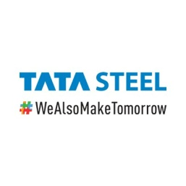 | Healthcare (Large) (Special Mention) | MANSI (Maternal And Newborn Survival Initiative)
SV EduSports Pvt Ltd |  | Education (Small) | Road to School Project
Avanti Fellows | 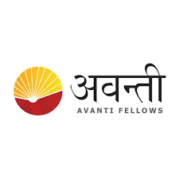 | Education (Large) | Creating the next-generation technology leaders from  rural India
Rakshak Foundation |  | Skill Development (Small) | Jute Story Beyond Bars
Wipro General Electric Healthcare Pvt Ltd |  | Skill Development (Large) | GE Healthcare Institute
Thriveni Earthmovers Pvt Ltd |  | Skill Development (Large) (Jury Recommendation) | Thriveni Industrial Security Academy (TISA)
Trust for Retailers & Retail Associates of India (TRRAIN) |  | Livelihoods | Pankh – Wings of Destiny
Shikhar Yuva Manch | 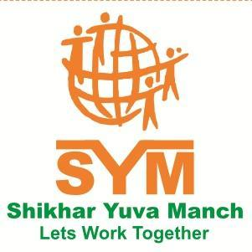 | Livelihoods | Holestic Rural Development Project
Jindal Steel & Power Limited (JSPL) |  | Environment | Natural Resource Management through Integrated Watershed Development & WADI (Orchard Development) in collaboration with NABARD and local implementing agency
LUPIN HUMAN WELFARE & RESEARCH FOUNDATION (LHWRF) |  | WASH (Water, Sanitation & Hygiene | River Rejuvenation Programme
Nuvoco Vistas Corp Ltd | 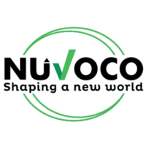 | Women Empowerment | ‘SAMRIDHI’ – Providing an Alternative and Sustainable  Source of Livelihood and Facilitating Women  Empowerment through Mushroom Cultivation
Kamlanayan Jamanalal Bajaj Foundation | 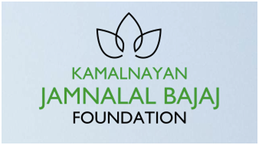 | Rural Development and Infrastructure | Reviving Rivers/Streams for Improving the Farmers’ Lifeline (Yashoda Basin project)
Hero Moto Corp Limited |  | Special Category (Old age, Specially Abled and others) | Project Enable
Cognizant |  | Employee Volunteering | 100^4 Program in Education – 100 Schools, 100% Pass, 100% Graduation, 100% Employability
Tata Steel Limited |  | CSR Project of the Year 2017-18 | Thousand Schools Programme (Enhancing School Education)
Hinduja Foundation | 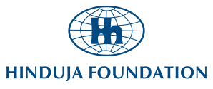 | CSR Project of the Year 2017-18 | शाश्वतग्राम – Sustainable Rural Development Program
Foundation for Excellence India Trust (FFEIT) |  | CSR Project of the Year 2017-18 (Jury Recommendation) | Sponsoring the education of academically gifted and financially deserving students in India pursuing degrees In Engineering (BE) and Technology (B. Tech) through a grant
ICICI Foundation for Inclusive Growth |  | CSR Foundation of the Year 2017-18 | ICICI Foundation for Inclusive Growth
WPP India CSR Foundation for WPP India | 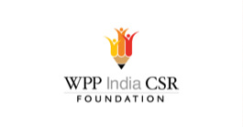 | Company with Best CSR Impacts | NA
Swades Foundation | 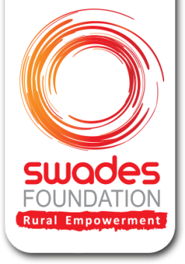 | CSR Implementing Agency of the Year 2017-18 | NA

